**Task 3: Multi-Cloud Architecture Documentation**

**Project Title:** Multi-Cloud Web Application Deployment

**Intern Name:** Vanshika Goyal  
**GitHub Repository:** <https://github.com/Vanshi-glitch/multi-cloud-backend>  
**Cloud Providers Used:** Azure (Backend) and AWS (Frontend)

### Objective:

To design and implement a multi-cloud architecture where the backend is hosted on Microsoft Azure and the frontend is deployed on Amazon Web Services (AWS), demonstrating interoperability between cloud platforms.

### Architecture Overview:

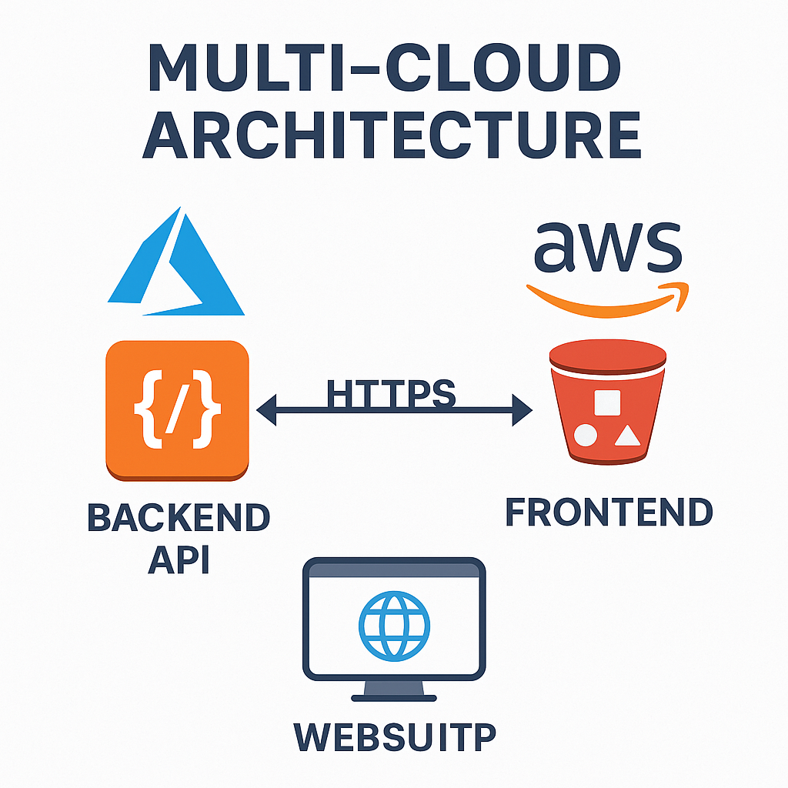**Architecture Diagram:**

* **Backend:** Hosted on Azure App Service
  + Automatically deployed using GitHub integration
  + Uses Python/Node.js backend (based on project requirement)
* **Frontend:** Hosted on AWS S3
  + Static HTML/CSS/JS files
  + Public bucket configured with static website hosting

### Step-by-Step Deployment:

#### 1. **GitHub Repository Setup**

* Created a GitHub repository named multi-cloud-backend
* Added and committed backend project files
* Used commands:
* git init  
  git remote add origin https://github.com/Vanshi-glitch/multi-cloud-backend.git  
  git add .  
  git commit -m "Initial Commit"  
  git push -u origin main

#### 2. **Backend Deployment to Azure**

* **Created Azure App Service** via Azure Portal
  + Runtime: Python / Node.js
  + Deployment source: GitHub
  + Repository: Vanshi-glitch/multi-cloud-backend
  + Branch: main
* Azure deployed the code automatically
* **Live URL:** <https://vanshika-flask-app.azurewebsites.net/>

#### 3. **Frontend Deployment to AWS S3**

* Created an S3 bucket named multi-cloud-frontend-vanshika
* Enabled static website hosting
* Uploaded index.html, style.css, and JS files
* Set permissions with public-read access:
* {  
   "Version": "2012-10-17",  
   "Statement": [  
   {  
   "Sid": "PublicReadGetObject",  
   "Effect": "Allow",  
   "Principal": "*",  
   "Action": "s3:GetObject",  
   "Resource": "arn:aws:s3:::multi-cloud-frontend-vanshika/*"  
   }  
   ]  
  }
* **Live URL:** <http://multi-cloud-frontend-vanshika.s3-website.ap-south-1.amazonaws.com>

### Tools and Technologies Used:

* GitHub
* Azure App Service
* AWS S3
* Visual Studio Code
* Terminal (PowerShell)

### Screenshots Attached:

* Azure App Service setup
* GitHub integration on Azure
* AWS S3 static website setup
* Final application hosted URLs

Outcome:

Successfully deployed a full-stack application using a multi-cloud setup. Demonstrated the ability to host backend and frontend on different cloud platforms and integrate them using web technologies.

### Conclusion:

This task provided hands-on experience in designing and implementing multi-cloud systems, leveraging GitHub for CI/CD, Azure for backend scalability, and AWS for reliable frontend hosting. It showcased the benefits of interoperability between cloud providers.

# Screenshots

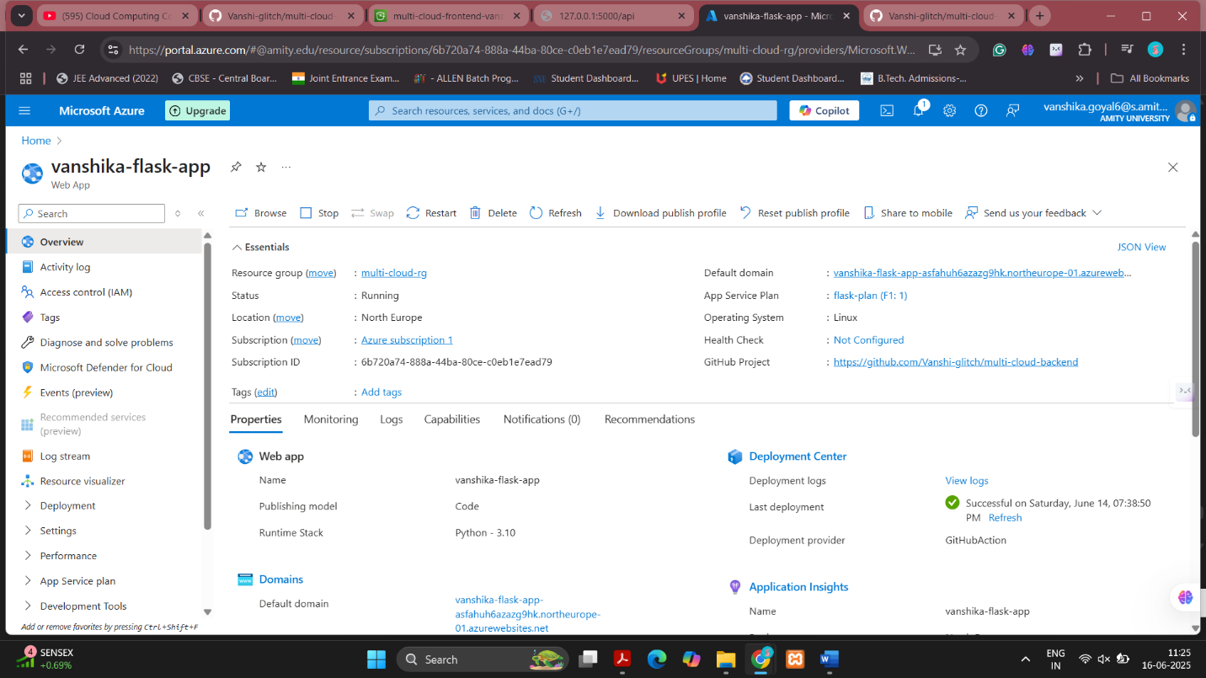

Figure : Azure App Service Overview

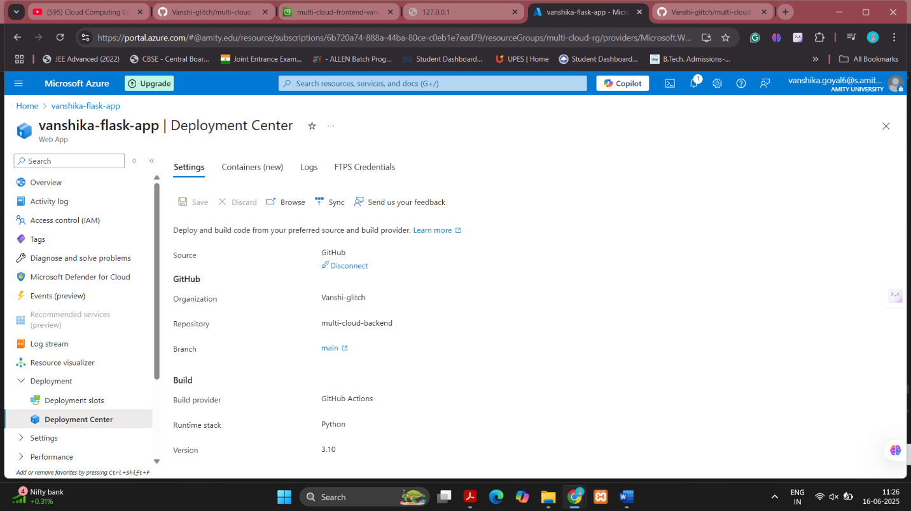

Figure : Azure Deployment Center connected to GitHub

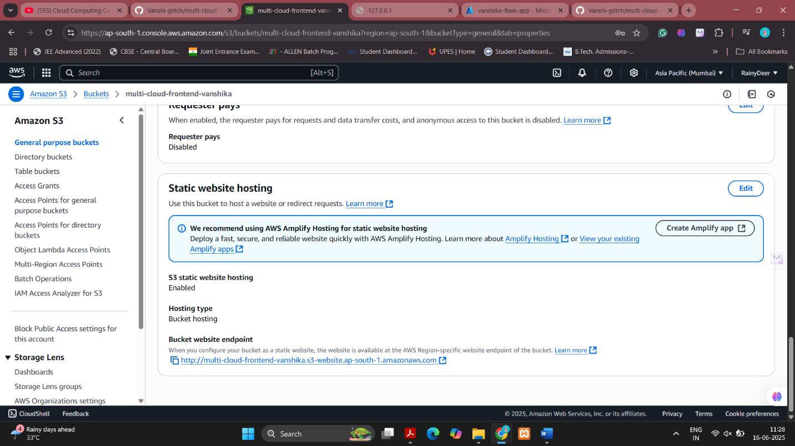

Figure : AWS S3 Static Website Hosting Configuration

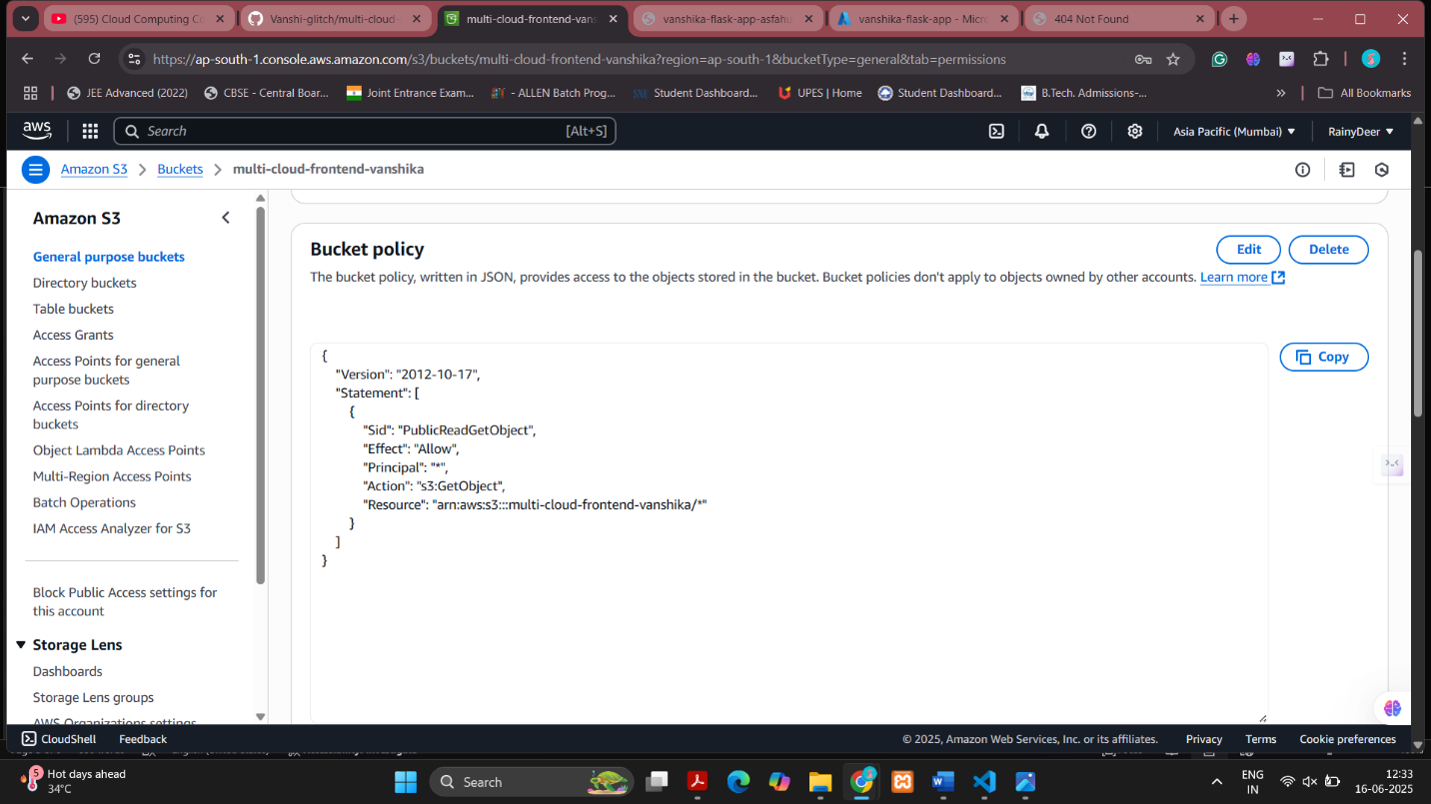

Figure : AWS S3 Bucket Policy for Public Access

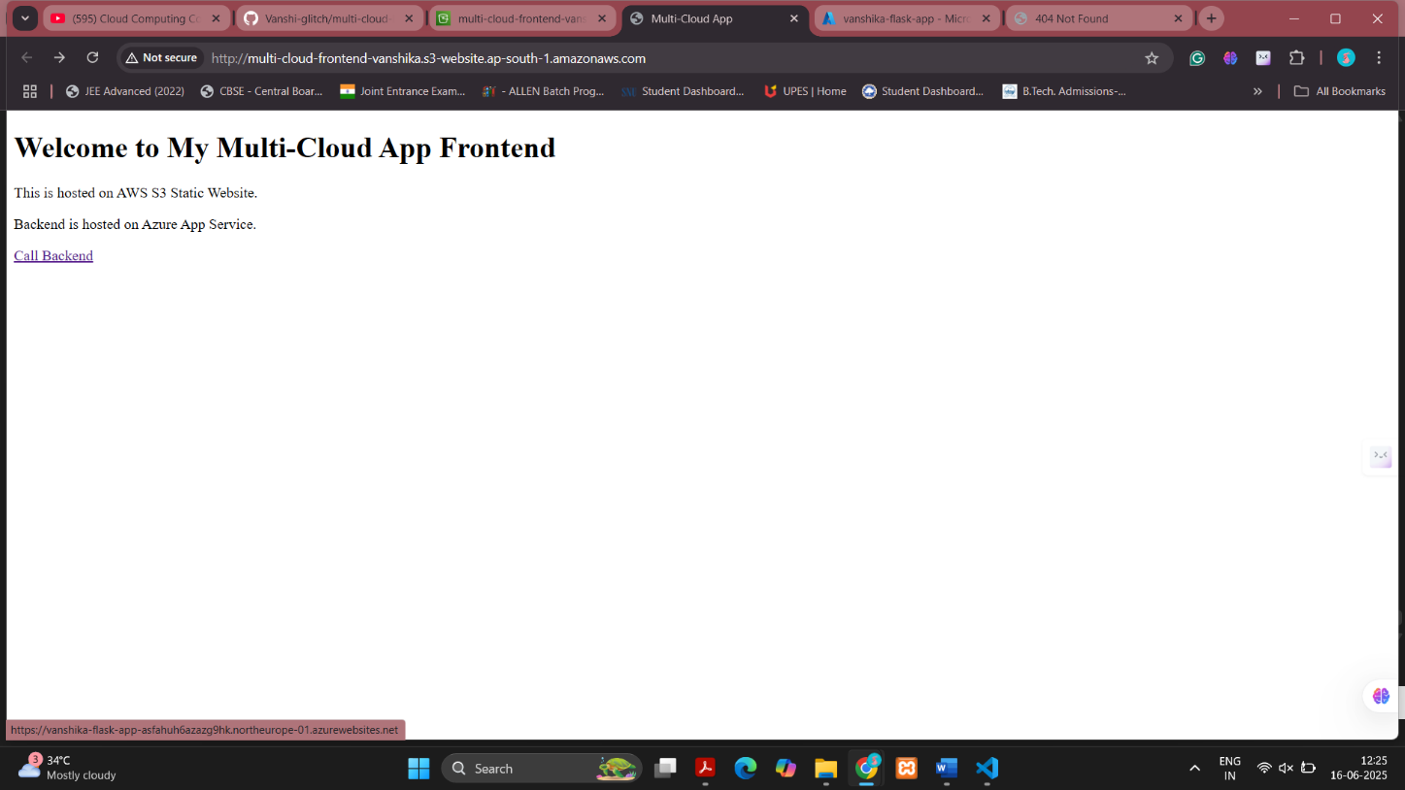

Figure .1: Frontend hosted on AWS calling backend on Azure (Frontend page)

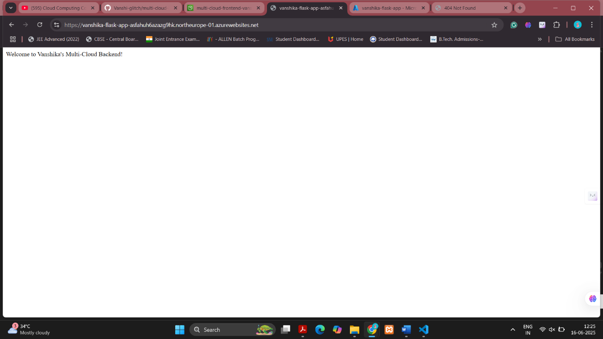

*Figure 5.2: Frontend hosted on AWS calling backend on Azure (Backend page)*